**How to Conduct a Scientific Experiment**

1. Make an observation

2. Ask a question

3. Think of a hypothesis

4. Experiment

5. Record the results

6. Discuss the results and make a conclusion

**Relevant Images**

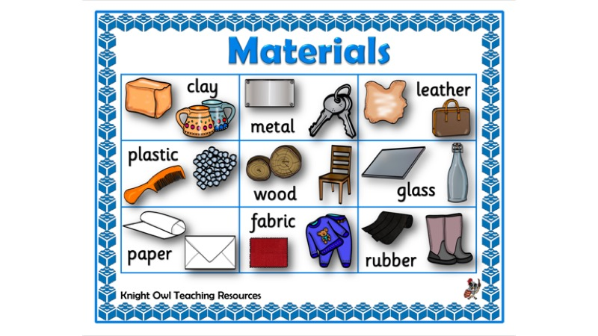



**Year 2 Knowledge Organiser**

Autumn 2 – Science; Uses of Everyday Material

**Science - What should I already know?**

I know that science is about questions and investigations.

I know how to think of questions and answers about the world around me.

I know that I can find answers by experimenting.

I know the name of some materials like wood, plastic metal and glass.

I can identify what objects are made out of.

I can describe the material using adjectives like smooth, bendy, soft, hard, rough.

I can compare and group together a variety of everyday materials on the basis of their simple physical properties.

**Key Vocabulary**

Materials Suitability Properties Squash Bend

Twist Stretch Wood Plastic Paper

Glass Metal Cardboard Fabric Rubber

Flexible Transparent Magnetic Durability Strength



<https://www.natgeokids.com/uk/discover/geography/general-geography/what-is-climate-change/>



<https://climatekids.nasa.gov/>

**Essential Facts**

Solids are one of the three states of matter and, unlike liquids or gases, they have a definite shape that is not easy to change.

Different solids have particular properties such as stretch, strength, or hardness that make them useful for different jobs.

The properties of materials can help us decide if it’s the best material to use when making specific items.

**Enquiry Questions**

Why are some materials more suitable than others?

What makes a material more suitable or unsuitable?

Can some items can be made by more than one material? If so why?

How can objects can be changed by squashing, bending, twisting and stretching